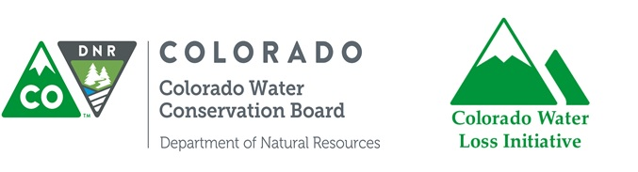Colorado Water Loss Initiative

Stage 1 Early Adopter Workshop

Date: Thursday, May 9th, 2019
Location: AWWA Headquarters
6666 W Quincy Ave, Denver CO 80235
Time: 8:00a – 3:30p
Lunch provided

RSVP required! If your utility is on the Early Adopter track, you can RSVP here:
https://docs.google.com/forms/d/e/1FAIpQLSeX7SImWgs5sDD6uEb51_CnSjQbGlbZegIOCXD0zVfis3Kg3w/viewform

